Cascading Style Sheets (CSS)

1. font-family: FAMILY_NAME, GENERIC_NAME;

-- In addition to specifying common fonts that are found on most operating systems, we can also specify non-standard, custom web fonts for use on our website.
-- Google Fonts is a free library of web fonts that you can use in your CSS by referencing the font's URL.
-- To import a Google Font, you can copy the font(s) URL from the Google Fonts library and then paste it in your HTML.
-- <link href="https://fonts.googleapis.com/css?family=Lobster" rel="stylesheet" type="text/css">
-- now you can Lobster font as family name.

generic name:-
-- The GENERIC_NAME is optional, and is a fallback font in case the other specified font is not available.
-- There are several default fonts that are available in all browsers. These generic font families include monospace, sgrid-row: 1;erif and sans-serif
-- Generic font family names are not case-sensitive. Also, they do not need quotes because they are CSS keywords.

BOX MODEL:-

2. Three important properties control the space that surrounds each HTML element: padding, margin, and border. also called THE BOX MODEL
*apply these properties to the div surrounding the text:-

-- An element's padding controls the amount of space between the element's content and its border.
-CSS allows you to control the padding of all four individual sides of an element with the padding-top, padding-right, padding-bottom, and padding-left properties.
- padding: 10px 20px 10px 20px; // clockwise notation
These four values work like a clock: top, right, bottom, left,

-- An element's margin controls the amount of space between an element's border and surrounding elements.
-If you set an element's margin to a negative value, the element will grow larger.
- CSS allows you to control the margin of all four individual sides of an element with the margin-top, margin-right, margin-bottom, and margin-left properties.
- margin: 10px 20px 10px 20px; // clockwise notation
These four values work like a clock: top, right, bottom, left,

-- border:-
Border property:-
border-color: green;
border-width: 10px;
border-style: solid;
border-radius:10px; // gives rounder border
if// border-radius:50%; // gives circular border

* margin left and right are cummulative, but top to bottom follows the best of two
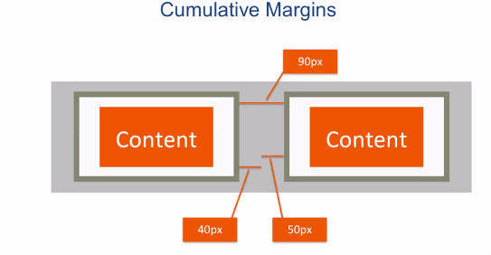
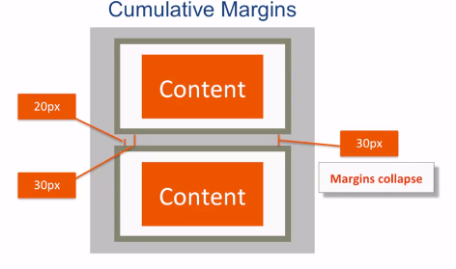

* the box model in general follow “content-box” , means width,padding,border are cummulative, like if you specify width as 300px the entire box will not be 300px , it will be more than that.
But CSS3 allows us to make it “border-box”.
Box-sizing: border-box; // use this property in the css
* instead of using this property in every css content, place it in *( universal ) selector, this selector does not use inheritence, it says select every element and apply it
*{
box-sizing: border-box;
}

* if we add more text in the box , then the box height of the box will increase automatically, we don’t want it, so we restrict the height of the box,
- eg, height: 50px;
but now the content will overflow, that also we dont want, so we use scroll feature
- overflow: auto; //only vertical scrolling
- overflow: scroll; // both vertical and horizontal scrolling

* you can also put image in the box
backgroung-image: url(“example.jgp”);

* for repeatation and position of the image you can use
background-repeat: ; // no-repeat, repeat-x, etc
background-position: ; // top, bottom, center, etc;

NOTE: instead of using several background property one by one, use all at one.
background: url(“ “) no-repeat right center blue;

BOX SHADOW:- (advanced topic)

* The box-shadow property applies one or more shadows to an element.
- The box-shadow property takes values for
- offset-x (how far to push the shadow horizontally from the element),
- offset-y (how far to push the shadow vertically from the element),
- blur-radius,
- spread-radius and
- color, in that order.
The blur-radius and spread-radius values are optional.
- box-shadow: 0 10px 20px rgba(0,0,0,0.19), 0 6px 6px rgba(0,0,0,0.23); //multiple shadow separated by comma.

3. color coding:-

-- hexadecimal coding, eg, #00FF00, #FA00FF
-- rgb coding , eg, rgb(0, 0, 0), rgb(255, 255, 255)
-- rgba(0,0,0,0.1)// last one is opacity (range from 0 to 1) , 0 being most
-- opacity can be specified separately
-- opacity: 0.7;
-- hue,saturation and lightness(hsl) property
background-color: hsl(180, 100%, 50%) // this gives cyan color

Hue is what people generally think of as 'color'. If you picture a spectrum of colors starting with red on the left, moving through green in the middle, and blue on right, the hue is where a color fits along this line.
In hsl(), hue uses a color wheel concept instead of the spectrum, where the angle of the color on the circle is given as a value between 0 and 360.

Saturation is the amount of gray in a color. A fully saturated color has no gray in it, and a minimally saturated color is almost completely gray. This is given as a percentage with 100% being fully saturated.

Lightness is the amount of white or black in a color. A percentage is given ranging from 0% (black) to 100% (white), where 50% is the normal color.

-- linear gradient
background: linear-gradient(gradient_direction, color 1, color 2, color 3, ...);
background: linear-gradient(90deg, red, yellow, rgb(204, 204, 255));

The first argument specifies the direction from which color transition starts - it can be stated as a degree, where 90deg makes a vertical gradient and 45deg is angled like a backslash. The following arguments specify the order of colors used in the gradient.

-- repeated linear gradient
used to make stripes of color shades

background: repeating-linear-gradient(
40deg,
yellow 0px,
yellow 40px,
black 40px,
black 80px );

SELECTORS:-
4. there are 3 types of selectors in css
- element,class(.),id(#)
- you can use multiple selectors by separating them by comma(,)
- you can give multiple class name to single element , but use id selector once because you can use them to select and modify specific elements with JavaScript.
- id attributes should be unique, because you can use them to select and modify specific elements with JavaScript.

5. other selectors:-
- [type='radio'] { // type attribute selector, remember to use = sign not :
margin: 20px 0px 20px 0px;
}

6. combining selectors
- Element With Class Selector(Selector.Class)
-- p.big{ // this means that to target every <p> element that has class ="big".
bla bla;
}[type='radio'] {
margin: 20px 0px 20px 0px;
}

- Child(Direct) Selector(Selector > Selector)
-- article > p{ //this target every <p> element that is a direct child of <article> element, but if p is inside div which is inside article then it not be effected.
bla bla;
}
-- other eg, article > .colored{
bla bla;
}

- Descendent Selector(Selector Selector)
-- article p{// every <p> element which is inside <article> get effected, not necessary direct.
bla bla
}

-- other eg, .colored p{
bla bla;
}

Presedence of selectors:-
7. Note: It doesn't matter which order the classes are listed in the HTML element.

--However, the order of the class declarations in the <style> section is what is important. The second declaration will always take precedence over the first.

8. Note: It doesn't matter which order you list id in css , id always wins.

9. inline styles will override all the CSS declarations in your style element.
eg, <h1 style="color:red">hello world</h1> // this is inline styling

11. In many situations, you will use CSS libraries. These may accidentally override your own CSS. So when you absolutely need to be sure that an element has specific CSS, you can use !important
-- eg, color: red !important; // just add !important after the declaration

!important > inline style > id > class > element - in priority order

12. pseudo-class selectors:-
-- they are predefined classes
-- selector:pseudo-class-name{

}
- hover:-
a:hover{
color:red; // will change the color of text to blue when we hover over the text
}
- ::before and ::after :-
These pseudo-elements are used to add something before or after a selected element.
For the ::before and ::after pseudo-elements to function properly, they must have a defined content property. This property is usually used to add things like a photo or text to the selected element

TEXT PROPERTIES:-
13. Ttext-transform property in CSS is used to change the appearance of text
text-transform: uppercase; // can also apply lowercase ,capitalize, etc;
14. other properties:-

font-size: 30px;
font-weight: 500; // how thick and thin the text should be
line-height: 20px; // this allows to change the height of each line in the block of text;

POSITIONING OF ELEMENT:-
15. Relative positioning
CSS treats each HTML element as its own box, which is usually referred to as the CSS Box Model. Block-level items automatically start on a new line . The default layout of elements in this way is called the normal flow of a document, but CSS offers the position property to override it.

-- When the position of an element is set to relative, it allows you to specify how CSS should move it relative to its current position in the normal flow of the page. It pairs with the CSS offset properties of left or right, and top or bottom. These say how many pixels, percentages, or ems to move the item away from where it is normally positioned.
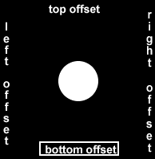

h2 {
position: relative;
bottom: 10px; // moves h2 to top by 10px
top: 10px; // moves h2 to bottom by 10px
right: 5px; // moves h2 to left by 5 px
left: 5px; // moves h2 to right by 5px
}

-- Changing an element's position to relative does not remove it from the normal flow - other elements around it still behave as if that item were in its default position

16. Absolue Positioning:-
The next option for the CSS position property is absolute, which locks the element in place relative to its parent container. Unlike the relative position, this removes the element from the normal flow of the document, so surrounding items ignore it. The CSS offset properties (top or bottom and left or right) are used to adjust the position.

h2 {
position: absolute;
bottom: 10px; // moves h2 to top by 10px
top: 10px; // moves h2 to bottom by 10px
right: 5px; // moves h2 to left by 5 px
left: 5px; // moves h2 to right by 5px
}

17. Fixed Positioning:-
The next layout scheme that CSS offers is thefixed position, which is a type of absolute positioning that locks an element relative to the browser window.
One key difference between the fixed and absolute positions is that an element with a fixed position won't move when the user scrolls.
NOTE: This is very useful in setting of Navigation Bar.

18. Float Property:-

-- Floating elements are removed from the normal flow of a document and pushed to either the left or right of their containing parent element. It's commonly used with the width property to specify how much horizontal space the floated element requires.
-- this property works in two column layout
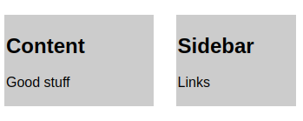
,example:-
#left {
float:left;
width: 50%;
}
#right {
// #left // #right
float:right;
width: 40%;
}

TRANSFORM PROPERTY:-
- transform:scale(1.5); //best applied with hover
this enlarges the box
- transform:skewX(24deg); // tilt the box horizontally by this degree
- transform:skewY(34deg); // tilt the box vertically by this degree

CSS ANIMATIONS

19. The animation properties control how the animation should behave and the @keyframes rule controls what happens during that animation.
- animation-name sets the name of the animation, which is later used by @keyframes to tell CSS which rules go with which animations.

- animation-duration sets the length of time for the animation.
Eg,
#anim {
animation-name: colorful; // you can give any name you want
animation-duration: 3s;
}

@keyframes colorful {
0% { // 0% is how the element displays in the opening scene.
background-color: blue;
top: 10px; // top offset property to it
}
100% { // 100% is how the element appears at the end, right before the credits roll
background-color: yellow;
left: 10px; //left offset property to it
}
}

- animation-fill-mode specifies the style applied to an element when the animation has finished.
animation-fill-mode:forwards; // it stays in this position even if duration is over
// generally used with hover
- animation-iteration-count: 3; // used to specify the iteration of the animation. Infinite is also used.

Animation-timing-function: linear; ease, ease out can also be used // this eases the animation

CSS FLEXBOX:-

-- Placing the CSS property display: flex; on an element allows you to use other flex properties to build a responsive page.

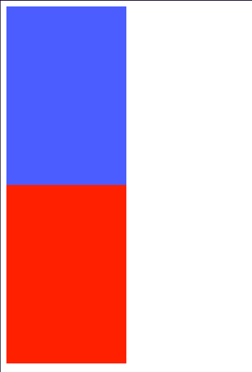
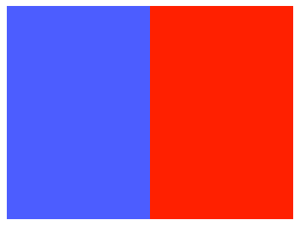
#box-container {
height: 500px;
display:flex;
}

before flex property after flex property

-- Adding display: flex to an element turns it into a flex container. This makes it possible to align any children of that element into rows or columns. You do this by adding the flex-direction property to the parent item and setting it to row or column. Default is row, we can apply row-reverse, column, column-reverse.

-- justify-content: use to align the content like
center, flex-start, flex-end, space-between, space-around, space-evenly

CSS GRID:-

RESPONSIVE DESIGN

Media Queries:-
-- Media Queries are a new technique introduced in CSS3 that change the presentation of content based on different viewport sizes. The viewport is a user's visible area of a web page, and is different depending on the device used to access the site.

@media (min-width: 1200px){ // for large devices
#p1{
width: 80%;
}
}
@media (min-width: 992px) and (max-width: 1199px{ // for medium devices
#p1{
width: 50%;
}
}

TWITTER BOOTSTRAP

Bootstrap is most popular HTML,CSS,JS framework for developing responsive, mobile-first application on web.
Bootstrap uses a responsive 12 column grid layout and has design templates for:

buttons
images
tables
forms
navigation

* To add bootstrap css to web page, add this in head element, before your css file link so that you can override it bootstrap.
<link rel="stylesheet" href="https://stackpath.bootstrapcdn.com/bootstrap/4.1.3/css/bootstrap.min.css" integrity="sha384-MCw98/SFnGE8fJT3GXwEOngsV7Zt27NXFoaoApmYm81iuXoPkFOJwJ8ERdknLPMO" crossorigin="anonymous">

Responsive breakpoints:-
Since Bootstrap is developed to be mobile first, we use a handful of media queries to create sensible breakpoints for our layouts and interfaces. These breakpoints are mostly based on minimum viewport widths and allow us to scale up elements as the viewport changes.

Bootstrap primarily uses the following media query ranges—or breakpoints—in our source Sass files for our layout, grid system, and components.

// Extra small devices (portrait phones, less than 576px)
// No media query for `xs` since this is the default in Bootstrap

// Small devices (landscape phones, 576px and up)
@media (min-width: 576px) { ... }

// Medium devices (tablets, 768px and up)
@media (min-width: 768px) { ... }

// Large devices (desktops, 992px and up)
@media (min-width: 992px) { ... }

// Extra large devices (large desktops, 1200px and up)
@media (min-width: 1200px) { ... }

Containers:-
-- Containers are the most basic layout element in Bootstrap and are required when using our default grid system

- class=”container”
Choose from a responsive, fixed-width container (meaning its max-width changes at each breakpoint)
- class=”container-fluid”
Use .container-fluid for a full width container, spanning the entire width of the viewport.

-- class=”img-responsive”
sets the image to be responsive

NOTE:-
-- we can add multiple class to it by putting space in it
eg, class=”red-text text-center”

Button styling:-
-- styling for button element
eg, class=”btn btn-default”
to make button stretch wide, add “btn-block” class to it
-- btn-primary class is used to add color to the button
-- The btn-info class is used to call attention to optional actions that the user can take.
-- The btn-danger class is the button color you'll use to notify users that the button performs a destructive action, such as deleting a cat photo. these buttons still need the btn and btn-block classes.

GRID SYSTEM:-
- this is used to put element side by side.
-- Containers provide a means to center and horizontally pad your site’s contents.
-- Rows are wrappers for columns
-- In a grid layout, content must be placed within columns and only columns may be immediate children of rows.

-- Column classes indicate the number of columns you’d like to use out of the possible 12 per row. So, if you want three equal-width columns across, you can use .col-4.
-- Bootstrap's col-md-* class. Here, md means medium, and * is a number specifying how many columns wide the element should be. -xs(extra small), -sm(small), lg(large), xl(extra large).
-- <div class="col-md-auto"> // Variable width content
-- by inserting a <div class="w-100"></div> where you want the columns to break to a new line.

<div class=”container”>
<div class=”row”>
<div class=”col-md-4”>col1 </div> //col-size-span
.....
.....
</div>
</div>

Alignment:-

-- <div class="row align-items-start">
-- <div class="row align-items-center">
-- <div class="row align-items-end">
// these will align the entire row vertically
-- <div class="col align-self-start">
-- <div class="col align-self-center">
-- <div class="col align-self-end">
// these are used to custom align columns vertically

-- <div class="row justify-content-start">
-- <div class="row justify-content-center">
-- <div class="row justify-content-end">
-- <div class="row justify-content-around">
-- <div class="row justify-content-between">
// horizontal alignment

ICONS:-

* Font Awesome is a convenient library of icons.
-- <link rel="stylesheet" href="https://use.fontawesome.com/releases/v5.8.1/css/all.css" integrity="sha384-50oBUHEmvpQ+1lW4y57PTFmhCaXp0ML5d60M1M7uH2+nqUivzIebhndOJK28anvf" crossorigin="anonymous">

* The i element was originally used to make other elements italic, but is now commonly used for icons.
Eg, <i class="fas fa-thumbs-up"></i> // this creates a thumbs up icon.

<button class="btn btn-block btn-primary"><i class="fas fa-thumbs-up"></i> Like</button>

For more fonts go to: https://fontawesome.com/

NOTE:-
* Bootstrap has a class called ‘well’ that can create a visual sense of depth for your columns.

